Ideation Phase
Define the Problem Statements

Date | 25 July 2025
Team ID | PNT2025TMID08395
Project Name | Visualizing Housing Market Trends: An Analysis of Sale Prices and Features using Tableau
Maximum Marks | 2 Marks

Customer Problem Statement Template:
Create a problem statement to understand your customer's point of view. The Customer Problem Statement template helps you focus on what matters to create experiences people will love.
A well-articulated customer problem statement allows you and your team to find the ideal solution for the challenges your customers face. Throughout the process, you’ll also be able to empathize with your customers, which helps you better understand how they perceive your product or service.
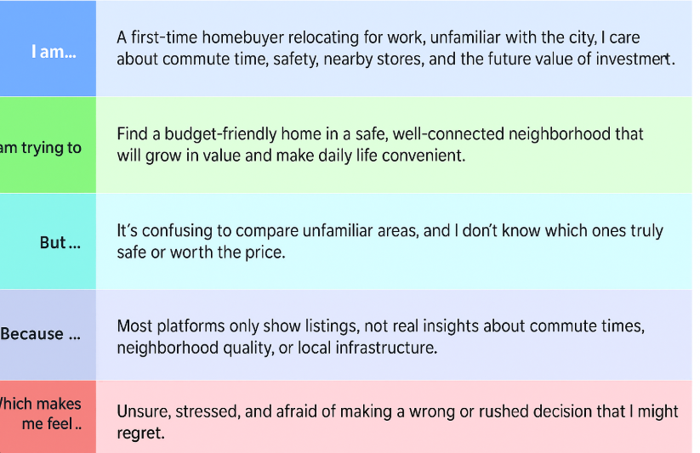s
Reference: https://miro.com/templates/customer-problem-statement/
Example:
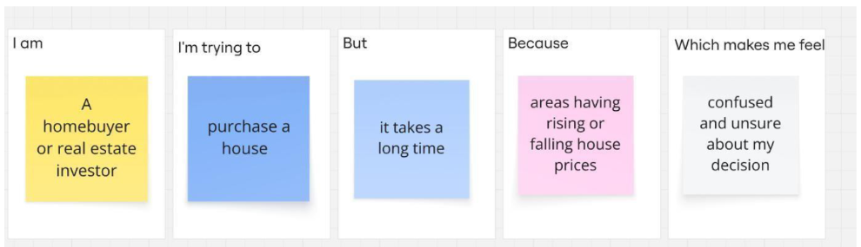
Problem Statement (PS) | I am (Customer) | I’m trying to | But | Because | Which makes me feel
PS-1 | a real estate analyst | identify trends in house sale prices | the data is overwhelming | it's scattered, unfiltered, and hard to visualize | Overwhelmed
PS-2 | a home buyer / investor | understand what features influence house prices | I can't draw clear insights | there’s no clear visual link between features and sale price | Confused / Unsure

